**Creating A Docker File**

1. **Requirments.txt**

flask

ibm_db

ibm-cos-sdk

1. **Creating Docker file**

# Use an official Python runtime as a parent image

FROM python:3.8

# Set the working directory in the container

WORKDIR /app

# Copy the current directory contents into the container at /app

COPY . /app/

# Install any needed packages specified in requirements.txt

RUN pip install --no-cache-dir -r requirements.txt

# Make port 80 available to the world outside this container

EXPOSE 80

# Define environment variable

ENV NAME World

# Run app.py when the container launches

CMD ["python", "app.py"]

1. **Build the docker image**

docker build -t myapp .

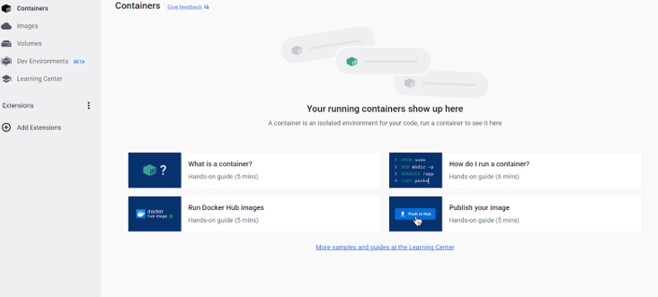

1. **Run the docker image**

docker run -p 4000:80 myapp

1. **Pushing docker image to Docker hub**
2. Create an Account on Docker Hub
3. Use the docker login command to log in to your Docker Hub account

docker login

1. Before pushing the image, make sure to tag it with our Docker Hub username and the repository name. Replace myapp with our image name and repository name.

docker tag myapp caroline/myapp

1. Push the Image

docker push caroline/myapp